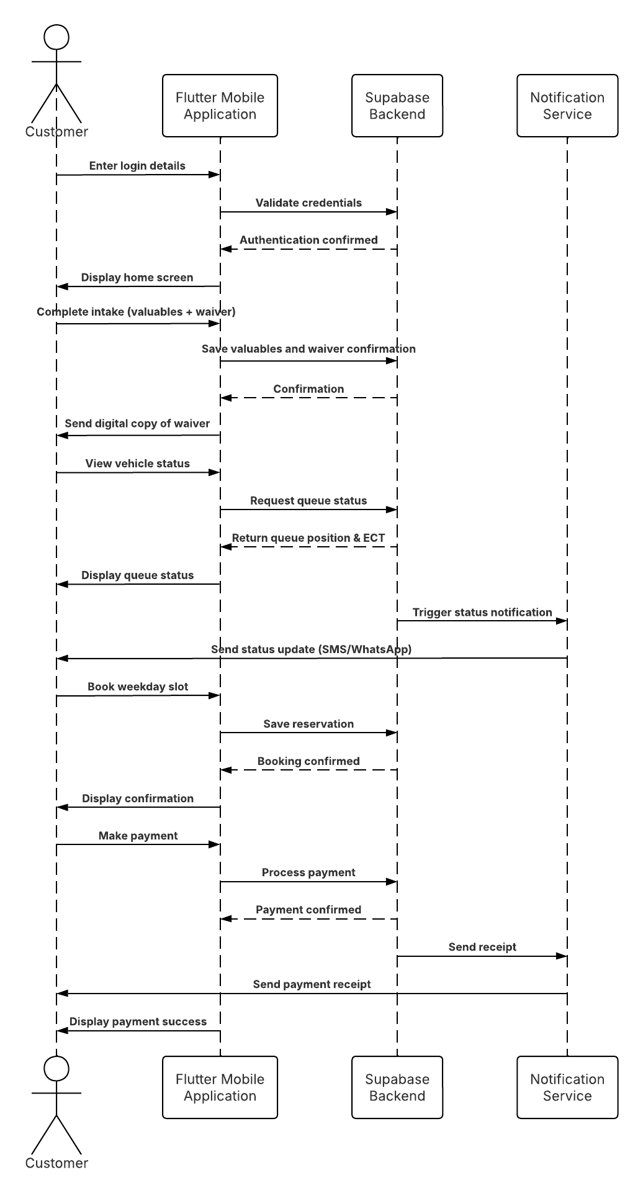
The Sequence Diagram illustrates the dynamic interactions between the Customer, Staff, and the system components of the Lifestyle Square Car Wash Management System. It shows the chronological flow of messages exchanged between actors and objects to complete the main use cases: Registration/Login, Request Service, Join Queue, Manage Queue, Update Status, and Make a Payment.

The diagram focuses on the time-ordered sequence of events that occur when a customer requests a car wash service and staff manage the vehicle through the operational workflow.

Step-by-Step Description of Interactions

- Customer → Flutter App: Customer enters login details, which are validated by Supabase, and the home screen is displayed.
- Customer → Flutter App → Supabase: Customer submits vehicle information, which is saved and confirmed.
- Customer → Flutter App → Supabase: Customer completes the valuables checklist, which is saved and confirmed.
- Customer → Flutter App: Customer confirms the digital liability waiver as mentioned on FR3.
- Flutter App → Supabase: Waiver confirmation is saved and confirmed as mentioned on FR3.
- Flutter App → Notification Service → Customer: A digital copy of the waiver and inventory is sent to the customer as mentioned on the FR4.
- Customer → Flutter App → Supabase: Customer views queue status; Supabase returns the queue position and ECT, which is displayed.
- Supabase → Notification Service → Customer: A status update is triggered and sent to the customer.
- Customer → Flutter App → Supabase: Customer books a weekday slot; the reservation is saved and confirmed.
- Customer → Flutter App → Supabase: Customer makes a payment; Supabase processes it and triggers a receipt.
- Notification Service → Customer: Payment receipt is sent, and the app displays payment success.

The Link

https://lucid.app/lucidchart/ebd65c31-ab81-416f-a49d-c49d54538693/view

Asp.net web and Staff sequence diagram
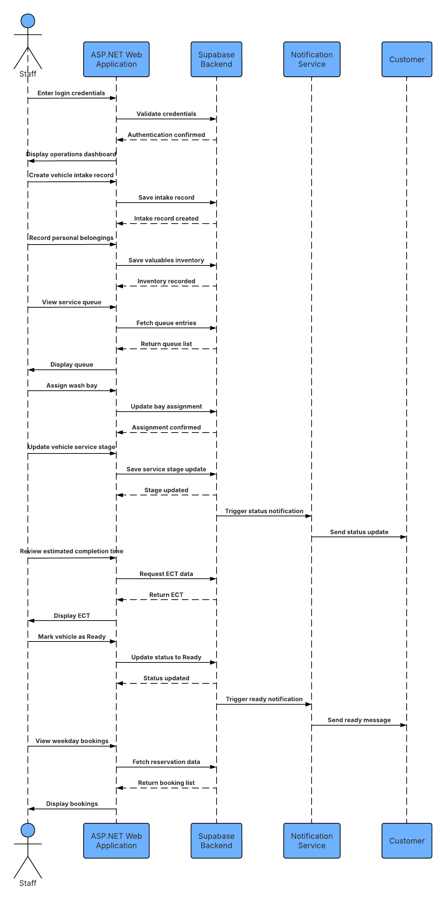
Step-by-Step Description of Interactions

- Staff → ASP.NET Web : Staff enters login credentials, which are validated by Supabase, and the operations dashboard is displayed.
- Staff → ASP.NET Web → Supabase: Staff creates a vehicle intake record, which is saved and confirmed.
- Staff → ASP.NET Web → Supabase: Staff records personal belongings found inside the vehicle, which is saved and confirmed.
- Staff → ASP.NET Web → Supabase: Staff views the service queue; Supabase returns the queue list, which is displayed.
- Staff → ASP.NET Web → Supabase: Staff assigns a wash bay to a vehicle, and the assignment is saved and confirmed.
- Staff → ASP.NET Web → Supabase: Staff updates the vehicle's service stage (e.g., Washing, Polishing, Vacuuming). Supabase saves the update and triggers a status notification to the customer.
- Staff → ASP.NET Web → Supabase: Staff reviews the estimated completion time; Supabase returns the ECT data, which is displayed.
- Staff → ASP.NET Web → Supabase: Staff marks the vehicle as Ready. Supabase updates the status and triggers a "Ready for collection" notification to the customer.
- Staff → ASP.NET Web → Supabase: Staff views weekday bookings; Supabase returns the reservation list, which is displayed.

The Link
https://lucid.app/lucidchart/0828ef9f-e7e0-48d9-9d49-ea0897844e4f/view

